

Project Interim Report

On

Password Complexity Validator (Using Core Java & OOP Concepts)
RU-100-01-00012
Object Oriented Programming with Java

SESSION: 2025-26

Submitted By Ranjan Kumar RU-25-11125

Bachelor of Technology in Computer Science & Engineering in association with Google

Under the Guidance of Mr. Ashish Shivhare

SCHOOL OF COMPUTER SCIENCE AND ENGINEERING RUNGTA INTERNATIONAL SKILLS UNIVERSITY
BHILAI, CG

(April 2026)

Abstract
The Password Complexity Validator is a Java-based project developed using Object-Oriented Programming (OOP) concepts. The system validates passwords according to predefined security requirements. It checks minimum password length, presence of numeric characters, and inclusion of uppercase letters. The project demonstrates secure coding practices and modular software development using separate classes for data storage and validation.

Introduction
Strong passwords are essential for protecting user accounts and confidential information. This project implements a Password Complexity Validation System using Java and OOP principles. User credentials are stored in a dedicated class while validation logic is handled separately. This design improves maintainability, reusability, and security.

Scope
This project is suitable for educational purposes and small-scale authentication systems. Future enhancements may include special-character validation, password strength ratings, database integration, GUI development, and advanced security checks

System Requirements
Hardware:
• Computer/Laptop with minimum 4 GB RAM
Software:
• Java JDK
• VS Code / Eclipse / IntelliJ IDEA
• Windows/Linux Operating System

Methodology
1. Create UserAccount class.
2. Store username and password using private fields.
3. Create SecurityValidator class.
4. Implement isValid() method.
5. Check password length (minimum 8 characters).
6. Check for at least one numeric digit.
7. Check for at least one uppercase letter.
8. Combine validation rules.
9. Display validation result.

Flowchart

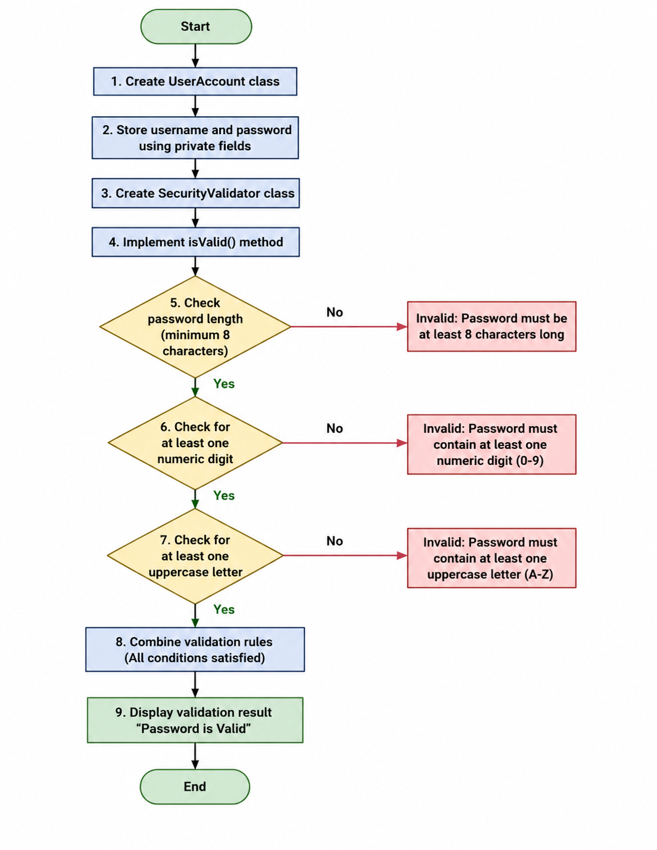

Implementation

UserAccount Class:
• Stores username and password.
• Uses encapsulation through private fields and getter methods.
SecurityValidator Class:
• Handles password validation logic.
• Verifies all required security conditions.
Main Class:
• Creates UserAccount object.
• Calls SecurityValidator.
• Displays validation result.

Gantt Chart
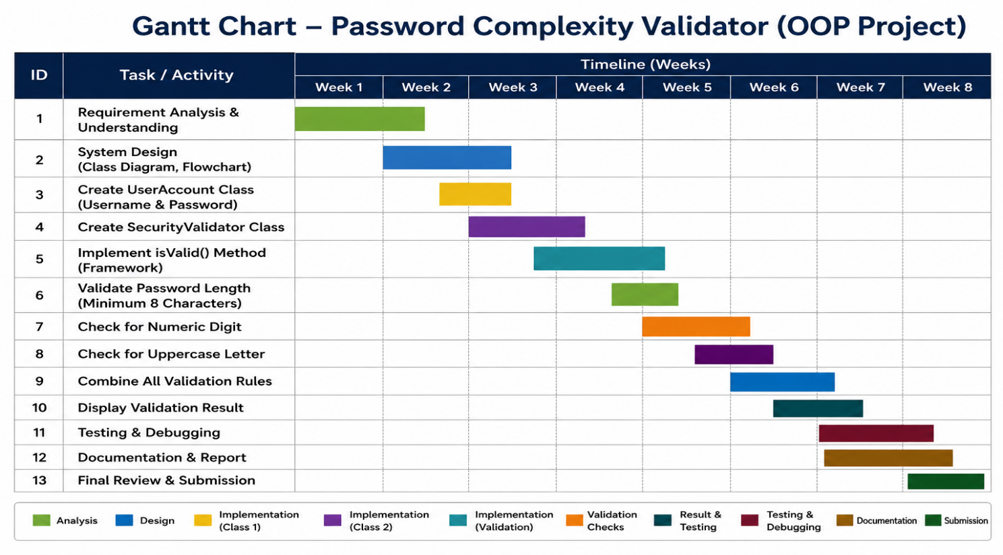

Conclusion
The Password Complexity Validator project successfully demonstrates the application of Object-Oriented Programming (OOP) concepts to create a secure and modular password validation system. By separating user data management and validation logic into different classes, the program achieves better organization, maintainability, and scalability. The system effectively verifies password strength by checking minimum length, numeric digits, and uppercase letters, helping enforce basic security standards. This project enhances understanding of encapsulation, class design, string manipulation, and validation techniques while promoting secure coding practices in Java.

References Book Format:
[1] Author(s), *Book Title*, Edition. City: Publisher, Year.

Example:
[1] H. Schildt, *Java: The Complete Reference*, 11th ed. New York: McGraw-Hill, 2018.

Website Format:
[2] Author (if any), "Title of page," Website Name. [Online]. Available: URL

Example:
[2] Oracle, "Java Documentation," Oracle. [Online]. Available: https://docs.oracle.com

Conference Paper
Format:
[3] Author(s), "Paper title," in Proc. Conference Name, year, pp.
Example:
[3] S. Kumar, "AI in Education," in Proc. IEEE Conf. on AI, 2021, pp. 120-125.

Journal Article
Format:
[4] Author(s), "Title of paper," Journal Name, vol., no., pp., year.
Example:
[4] A. Sharma and R. Gupta, "Machine Learning Techniques," International Journal of AI, vol. 5,
no. 2, pp. 45-50, 2020.

